Day 2:

Dockerize the flask application

* Create a AWS ACCT, Launch a EC2 instance
* Create a new pair key
* Open the cmd – connect to your instance using its public dns. (check in SSH client)
* Install docker

ISSUE 1: PERMISSION DENIED WHRN CONNECTIONG TO DOCKER DAEMON SOCKET

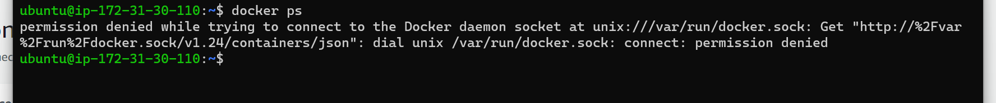

Sol: check with cmd “whoami” to see who is the user



We are using Current USER.

When you run **docker ps**, you get a list of running containers along with various details about each container. So, when you see the output of docker ps, it's showing you information about the Docker containers that are currently running on your system.

